Grade:IV Examples on Factors

Examples on factors on different types of questions on factors are discussed here step-by-step.
1. Find all the factors of 42.
Solution:
According to properties of factors, 1 and 42 are the factors of 42.
Now we find the numbers which completely divide 42.
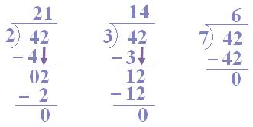
Thus, 1, 2, 3, 7 are complete dividers.
2 x 3 = 6; 3 x 7 = 21; 2 x 7 = 14; are also divisors.
Hence, 1, 2, 3, 6, 7, 14, 21 and 42 are the factors of 42.

